

ITA0324-Mobile Computing

Name: A. Anusha Reg no:192472083

Slot: C Course Name: Mobile Computing

Experiment 4: Mobile Network Protocol Stack
Aim: To create a visual representation highlighting the key elements of mobile network protocol stacks.
Procedure:
- Open Figma and create a new design file.
- Create a frame for the protocol stack diagram.
- Draw separate boxes for the Physical and Data Link layers.
- Add Network, Transport, and Application layers.
- Write the main function of each layer inside its box.
- Arrange the layers vertically and connect them using arrows.
- Apply different colors and labels to make the diagram easy to understand.

Output:

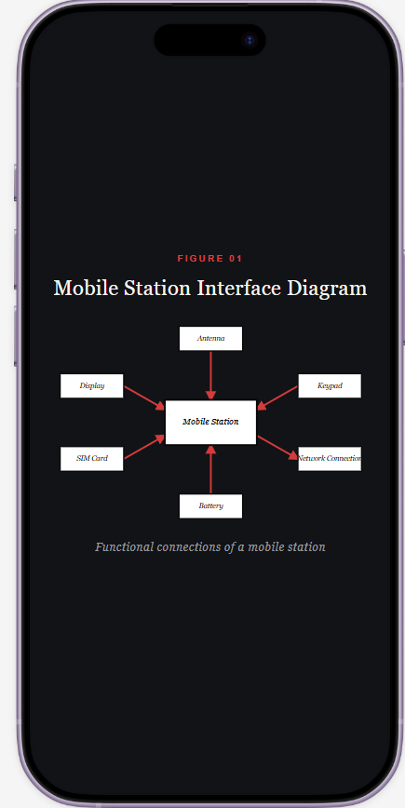

Result: Thus, a visual representation of the mobile network protocol stack was created successfully.

